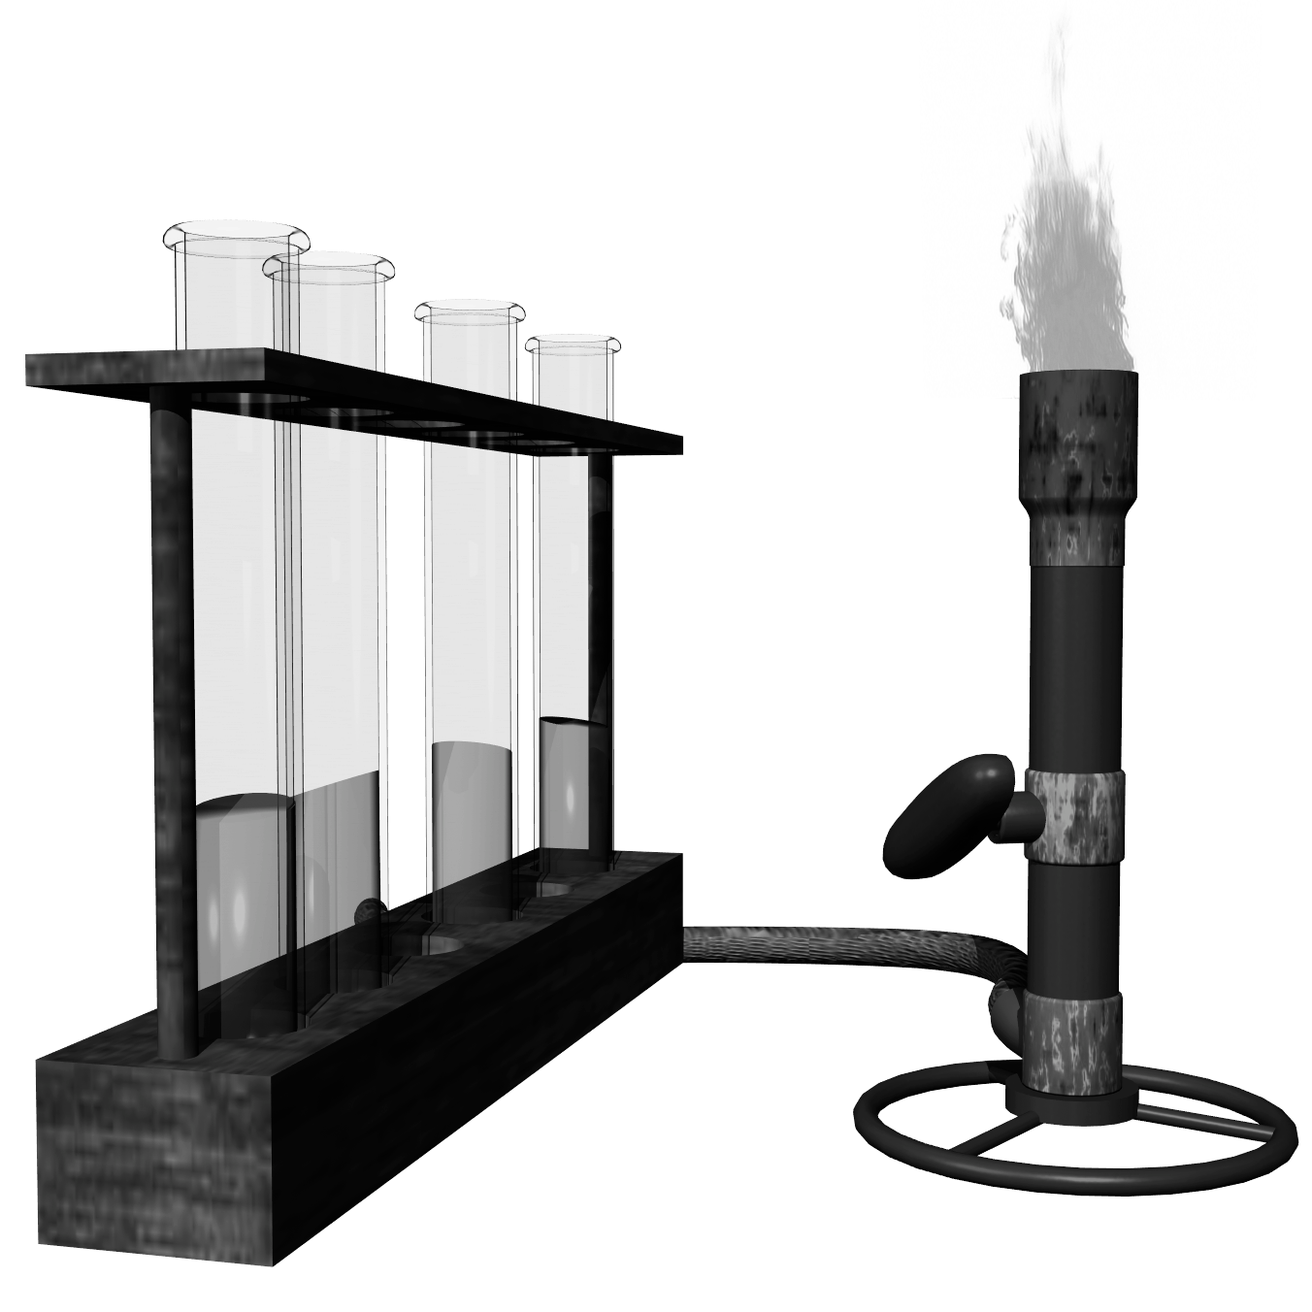
Name___________________________________________Date________________________Period____
Chemistry Laboratory Techniques Lab
Academic Chemistry
Chapter 0

Objectives:
- To practice the proper procedure for lighting a Bunsen burner.
- To practice the correct method of using an electronic balance.
- To practice the proper way to fold filter paper and set up a filtering apparatus.
- To identify the meniscus and accurately measure water using a graduated cylinder.
- To show the correct procedure for boiling water.

Materials:
Bunsen burner Wire gauze Stirring Rod
Striker Funnel Paper clip
Filter paper Clay triangle (optional) Coffee
250 mL Beaker 50 mL Graduated cylinder Ring stand and iron ring
50 mL Beaker Watch glass

Bunsen Burner Background:
The classic device for providing heat in a laboratory experiment is the Bunsen burner. The essential
construction of a Bunsen burner is shown in Figure 1. The gas enters the burner at the base, and its
supply is regulated externally by the gas cock. As the gas streams upward through a jet inside the base,
air is pulled in through the air-intake hose just above the base. The amount of air can be controlled by
rotating a sleeve that fits over the holes in the barrel of the burner. Maximum air enters when the holes
in the sleeve match those in the barrel.

The proper method for lighting a burner is to close off the air supply, turn on the gas, and light. The
flame will be large and yellow. Gradually open the air intake until the flame takes on a blue color. For
maximum heat, open further so that two distinct zones appear, the inner of which is light blue and cone shaped. The hottest point of the flame is just above the top of this inner zone.

In some instances, when the air supply to the burner is increased, the flame blows out or detaches itself
from the burner tip. This means that the gas flow is too great and needs to be cut down. When
relighting, remember to shut off the air supply first.

Procedure: Be sure to check off all procedures immediately after they have been completed.
Lighting a Bunsen Burner
___1. Together as a class check the gas supply hose for any cracks in the
plastic or fraying of fabric.
___2. Together as a class, turn on the gas valve on the lab table (the valve should be
parallel to the hose).
___3. As quickly as possible light the Bunsen burner using a striker.
___4. Adjust the air supply so that there is an outer darker blue cone and inner tighter
blue cone.
___5. Turn off the Bunsen burner using the gas valve attached to the lab table.

Using a Graduated Cylinder
___1. Obtain a 50 mL graduated cylinder.
___2. Fill graduated cylinder with 25 mL of water from either the tap or wash bottle. A dropper may
need to be used to fill to the exact mark. Remember to read and record the value of the
meniscus in the data table.
___3. Save the graduated cylinder and water for the Massing Objects procedure.

Massing Objects
___1. Go to an electronic balance with the graduated cylinder and a 50 mL beaker.
___2. Pickup object 1: a paperclip.
___3. Zero or tare the electronic balance. Make sure that it reads 0.0 g before starting.
___4. Put the paperclip on the balance. Record the mass in Table 1. Make sure that the
correct units are used.
___5. Zero or tare the electronic balance. Take one weighing dish and place it on the
balance.
___6. Zero or tare the balance again. Make sure that it reads 0.0 g before starting ..
___7. Mass as close to 0.5 grams of coffee as possible. Record the mass in Table 1.
___8. Take out the 50 mL graduated cylinder filled with 25 mL of water.
___9. Zero or tare the electronic balance. Take a 50 mL beaker. Place it on the
balance. Zero or tare the balance again.
___10. Pour the 25 mL of water into the beaker. Record the mass in Table 1.
___11. Pour the coffee into the beaker with water and stir.
Creating a Filter
___1. Take one piece of filter paper.
___2. Fold the filter paper in half (this should be half of a circle).
___3. Fold the filter paper in half again (this should be a quarter of a circle).

___4. Attach an iron ring to the ring stand.
___5. Place a funnel in the metal ring of the ring stand. If the ring is
too large for the funnel, obtain a clay triangle to hold the funnel.
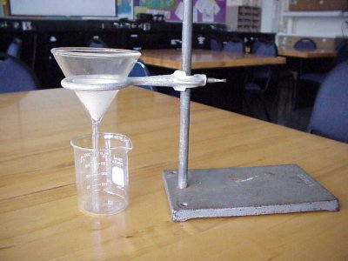
___6. Place the filter paper in the funnel and spread the filter paper so
that no solid would be able to get through (there should be a
side that is 1 sheet thick and another that is 3 sheets thick). A 250 mL
beaker should be placed below the tip of the funnel as to catch the liquid that
will be run through. At this point, use a wash bottle to gently moisten the
filter paper so that it will stick to the funnel.
___7. Pour the mixture with coffee grounds and water into the top of the filter
making sure that it doesn't go above the filter line.
___8. When it is finished draining, there should be liquid in the beaker and solid in
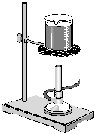
the filter. Throw away the used filter paper in the trash.
Boiling Water
___1. Obtain a ring stand, iron ring, piece of wire gauze, Bunsen burner, and 250 mL beaker.
___2. Attach the iron ring to the ring stand by tightening the clamp. The iron ring should be
roughly 3-4 inches above the Bunsen burner. .-
___3. Place the wire gauze on the iron ring.
___4. Place a beaker containing 100 mL of tap water on the wire gauze and a watch glass on top of the beaker.
___5. Carefully light the Bunsen burner.
___6. Allow the water to heat up until its boiling.

Data Table:

Object | Mass (g)
Paperclip

Coffee Grounds

25 mL Water

